**Build Project: Final Project**

**1. Prepare a nucleic acid handbook that talks about the structure and function of DNA**

Deoxyribonucleic Acid, or DNA, is the fundamental molecule that carries genetic information in all living organisms. Found primarily in the nucleus, DNA's unique structure and function allow it to serve as the blueprint for the biological processes that govern cellular activities and traits. Structurally, DNA consists of two complementary strands that twist to form a double helix, a shape essential to its stability and functionality. Each DNA strand comprises a chain of nucleotides, with each nucleotide containing three main components: a deoxyribose sugar, a phosphate group, and a nitrogenous base.

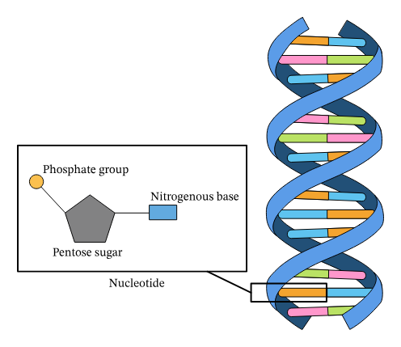

Present in the nucleus of all living organisms, DNA controls all the chemical changes and processes within cells, making it essential for sustaining life. As the primary carrier of genetic information, it ensures the transmission of inherited traits both within a species and across generations. The nitrogenous bases in DNA include adenine (A), thymine (T), cytosine (C), and guanine (G). Each base pairs specifically—adenine with thymine, and cytosine with guanine. This pairing forms the basis of DNA’s double-stranded structure, enhancing its stability and enabling it to replicate accurately.

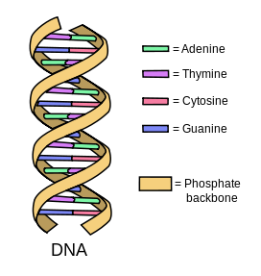

DNA’s double helix structure plays a critical role in its replication process. During cell division, DNA unwinds, allowing each strand to serve as a template for synthesizing a new complementary strand. This process, facilitated by the enzyme DNA polymerase, ensures each new cell receives an exact copy of the genetic material. Accurate replication is fundamental for growth, repair, and reproduction, allowing genetic information to be passed down through generations. DNA can be thought of as a molecule with an inherent drive to replicate itself, ensuring the continuity of life.

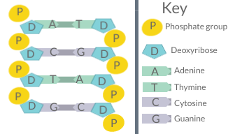

The sequence of nitrogenous bases within DNA constitutes the genetic code, which directs protein synthesis—an essential process for cellular function and overall organism health. Proteins, often called the "workhorses" of the cell, play key roles in structural, enzymatic, and regulatory functions. The genetic code is read in sequences called codons, groups of three bases that each correspond to a specific amino acid. DNA directs protein synthesis through two main processes: transcription, where DNA is transcribed into messenger RNA (mRNA), and translation, where mRNA guides the assembly of amino acids into proteins. This “instruction set” encoded within DNA provides cells with the necessary blueprints for life.

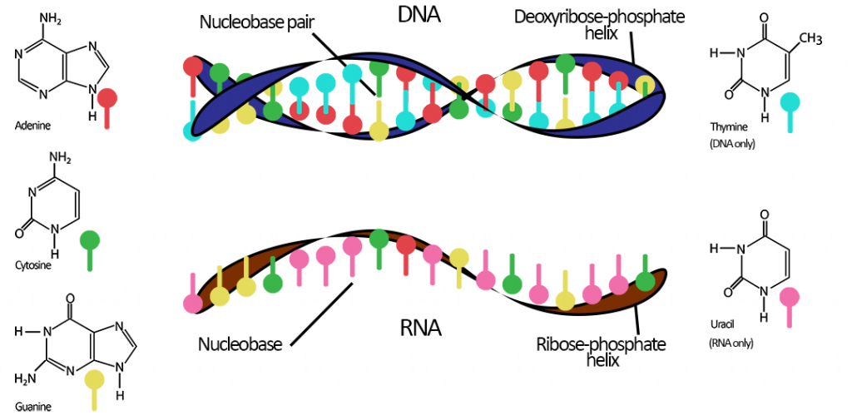

Beyond protein synthesis, DNA also regulates gene expression, controlling when and where specific genes are activated. This regulatory role enables cells to adapt and respond to environmental changes, ensuring appropriate cellular responses. DNA contributes to the uniqueness of each individual, as variations in sequences make each organism distinct. These variations in genetic sequences form the basis of an individual’s chromosomes, which collectively shape their biological traits and identity.

In sum, DNA is both a structural framework and a guiding set of instructions. Its structure, function, and ability to replicate make it the foundation of life, determining the characteristics and behaviors of all living organisms. As the basic form of life, DNA provides the genetic blueprint for all traits and ensures continuity across generations.

￼￼

**2. Explain DNA sequencing and what are the different types of mutations that can happen during sequencing**

DNA sequencing is a powerful technique used to determine the precise order of nucleotide bases (A, T, C, and G) in a DNA strand. Sequencing plays an essential role in genomic research, allowing scientists to decode the entire genome of an organism, identify genes, and gain insights into the genetic basis of various diseases. The sequence of nucleotides carries critical information that directs cellular processes, from protein synthesis to growth and development, by instructing the formation and regulation of proteins.

With advancements in technology, DNA sequencing has become faster and more affordable, particularly with the advent of Next-Generation Sequencing (NGS). NGS enables billions of DNA fragments to be sequenced simultaneously, a breakthrough that has transformed research fields such as personalized medicine, disease screening, and evolutionary biology. By reading the genetic code at this scale, scientists can better understand genome structure and function, paving the way for new therapies and diagnostics.

Mutations in DNA can arise during sequencing or other DNA processing steps, leading to changes in the genetic code. These mutations are classified into several types:

* **Substitution Mutations:** A substitution occurs when a single nucleotide is replaced by another—for example, a cytosine (C) being swapped for a thymine (T). If this mutation happens within a gene, it could result in a different amino acid being incorporated into a protein, potentially altering the protein's structure and function. Substitutions are often termed "point mutations" and can lead to genetic disorders if they disrupt essential protein functions.
* **Insertion Mutations:** In an insertion mutation, one or more extra nucleotides are added into the DNA sequence. Insertions can cause a shift in the reading frame (known as a frameshift mutation) if they occur within coding regions, resulting in a completely altered downstream sequence. Frameshift mutations often lead to nonfunctional proteins, as the reading frame shift can introduce premature stop codons or completely alter the amino acid sequence.
* **Deletion Mutations:** Deletions remove one or more nucleotides from a DNA sequence, similarly causing a frameshift if they occur within coding regions. Like insertions, deletions can disrupt the reading frame, leading to abnormal proteins that may malfunction or lose their function entirely. Frameshift mutations from deletions can be particularly harmful if they occur in genes critical to development or cellular function.

Mutations can be caused by errors in DNA replication, environmental factors (e.g., radiation, chemicals), or genetic predispositions. Understanding the nature of mutations and their effects is essential in fields like bioinformatics and medical genetics, as it allows researchers to investigate how genetic variations contribute to health and disease. By identifying mutations in disease-related genes, scientists can develop targeted therapies and advance precision medicine. Analyzing mutations through DNA sequencing offers insights into genetic diversity, disease mechanisms, and evolution, making it an invaluable tool in modern biology and medicine.